**DIGITAL FORENSICS LAB**

|  |  |
| --- | --- |
| Exercise 8 | |
| Name | S Shyam Sundaram |
| Registration Number | 19BCE1560 |
| Slot | L39+L40 |
| Faculty | Dr. Seshu Babu Pulagara |
| Date | 5th September, 2021 |

**AIM**

Working with DiskExplorer exploring disks and their file entries, partition table etc.

**Q1**

Navigate your NTFS drive by jumping to the partition table, boot record, Master file table or the root directory.

**A**

We select a drive first.

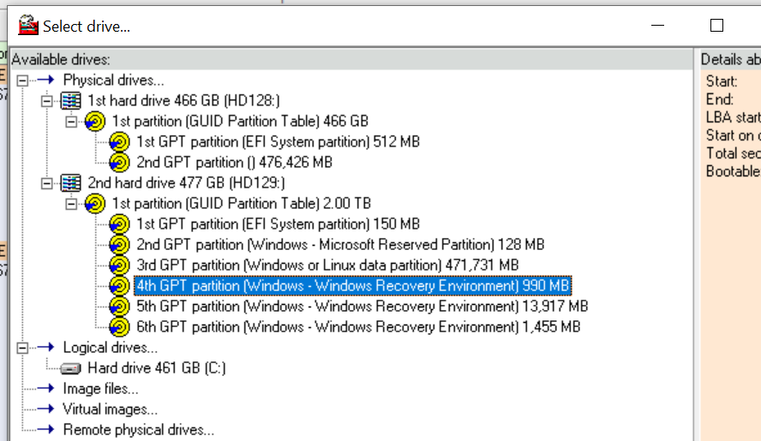

Partition table:

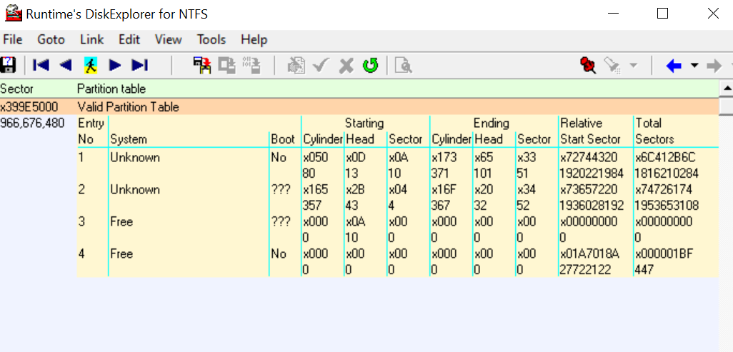

Boot Record:

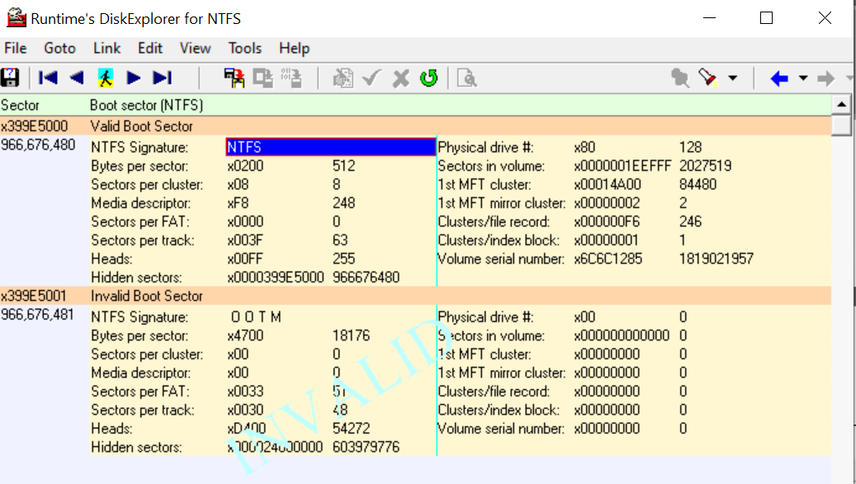

**Q2**

Choose between views such as hex, text, index allocation, MFT, boot record, partition table.

**A**

Hex View:

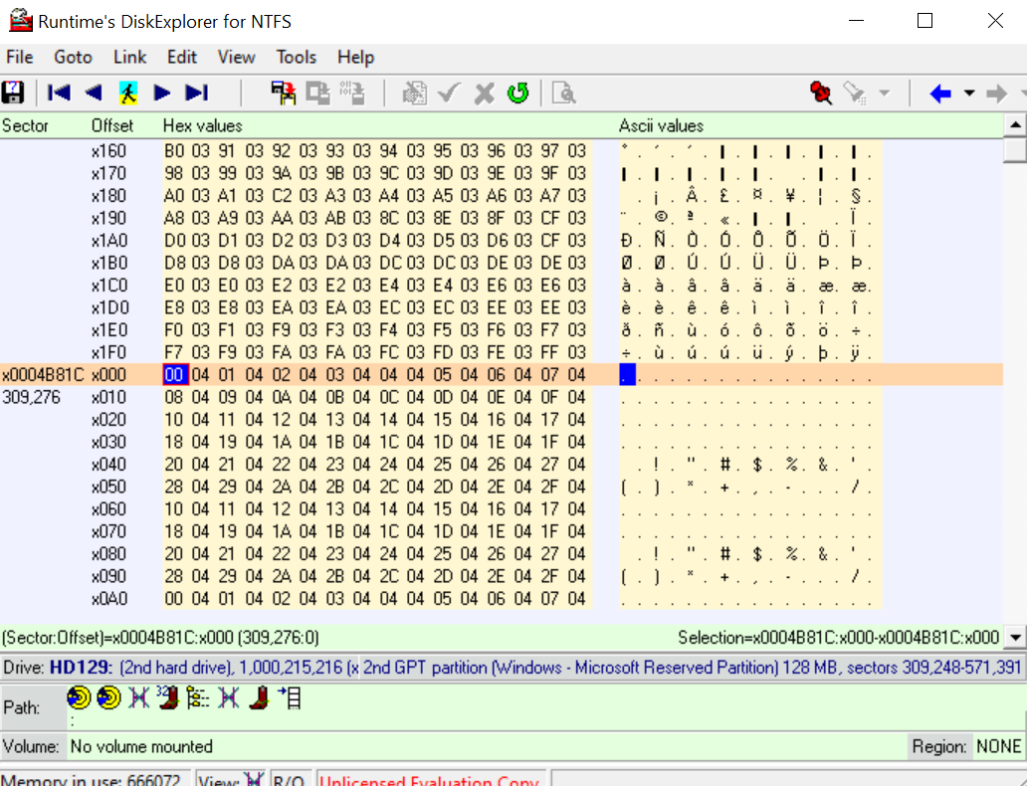

Text View:

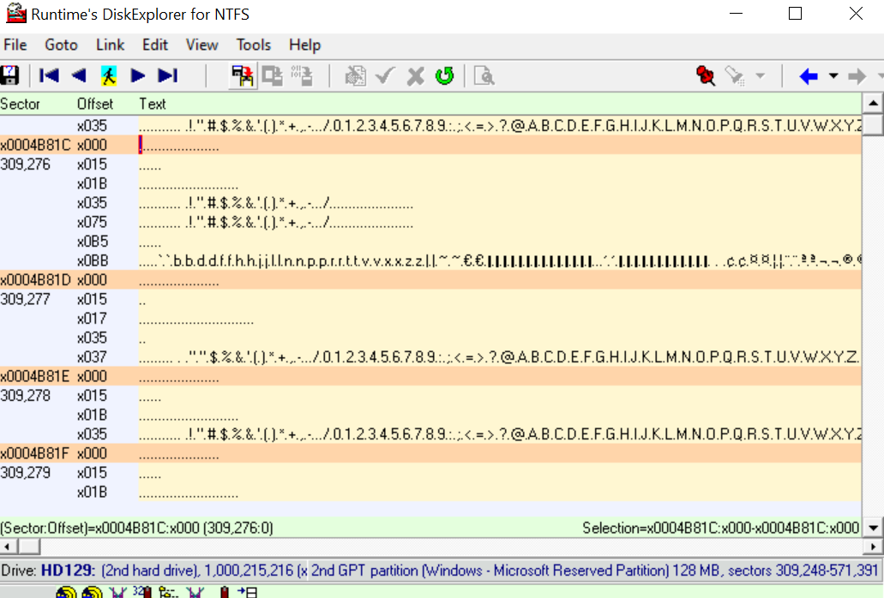

MFT:

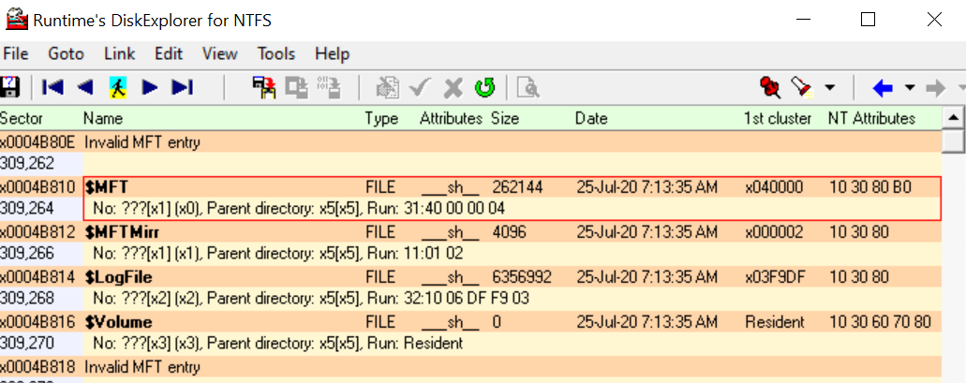

Boot record:

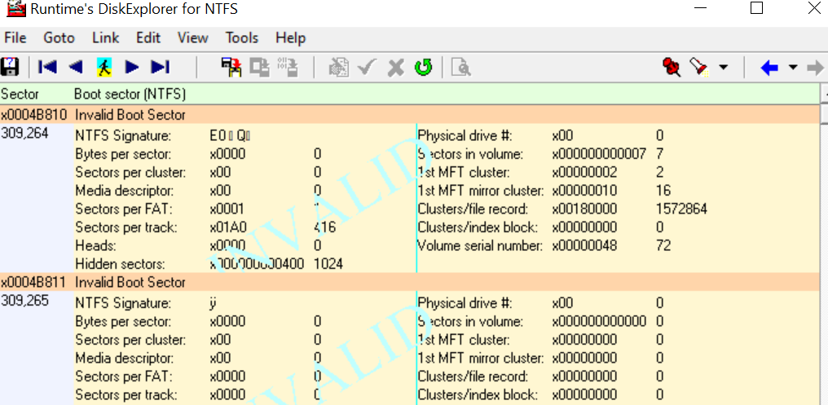

Partition table:

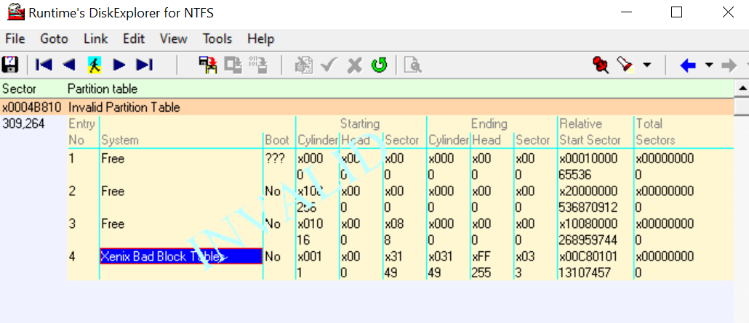

**Q3**

Inspect the file entry details, NT attributes etc.

**A**

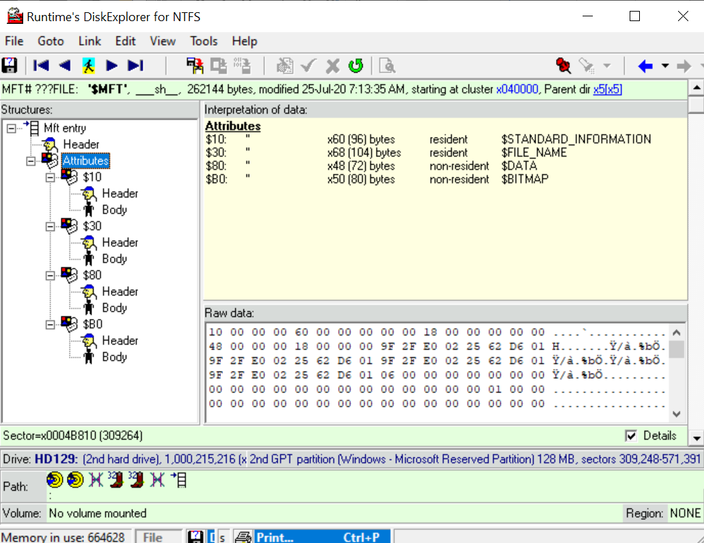

**OBSERVATIONS**

DiskExplorer is a low-level disk editor which we use to view and manipulate information at a sector level. It is also used for data recovery from drives. As seen in screenshots above, se can see what each sector of a drive holds. This is used in Digital Forensics so as to get an idea of the suspect drive and its contents. We can see the partition table

**CONCLUSION**

We have worked with DiskExplorer and discovered its capability and functionalities. The tool is powerful enough to interact with the disk on a sector level and recover data.